**SPRINT 0 PLANNING**



**Author: Imagineers Team**

**Date: 22/12/2016**

**Revision history**

|  |  |  |  |
| --- | --- | --- | --- |
| **Version** | **Date** | **Author** | **Notes** |
| 1.0 | 22/12/2016 | Thạch Nguyễn | Create document |
|  |  |  |  |

Contents

I. INTRODUCTION 4

1. Purpose 4

2. Audience 4

II. SPRINT 0 GOALS 4

III. SPRINT 0 BACKLOG 4

IV. SPRINT 0 TASK 5

V. SPRINT 0 DEFINTION OF DONE 6

# INTRODUCTION

## Purpose

This document describes how sprint 0 is planning. The plan describes in simple, straight forward term the processes required to ensure that the sprint 0 stories re estimated and ensures the goals of sprint 0.

## Audience

This document is created for Scrum team .

# SPRINT 0 GOALS

* This is the sprint planning
* The next goal is finishing the sprint 0 with selected stories with full artifacts that is defined in the “definition of done”
* Finishing the sprint 0 on time. With all the stories that was chosen to put in sprint 0
  + Analyze high level requirement
  + Develop product architecture
  + Establish Infrastructure
  + Build Product backlog
  + Establish Training Plan
  + Conduct Training

# SPRINT 0 BACKLOG

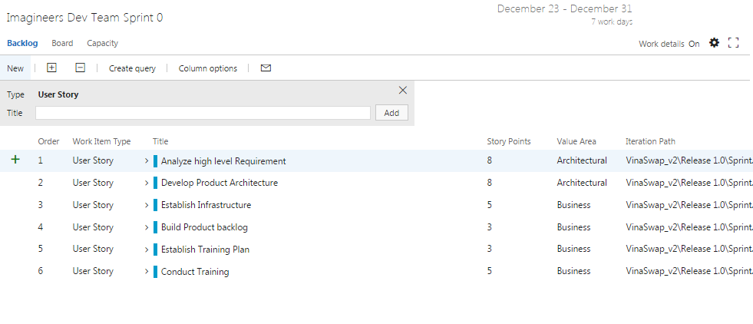

# SPRINT 0 TASK

|  |  |  |  |  |  |
| --- | --- | --- | --- | --- | --- |
| User story | Task | Assigned | Estimation (hrs) | Actual  (hrs) | Status |
| Analyze high level requirement  Conduct Training | Collect Requirements from meeting | Việt Đặng | 2 |  |  |
|  | Generate Business context | Phương Nguyễn | 5 |  |  |
|  | Write epic feature | Phương Nguyễn | 10 |  |  |
|  | Write user stories | Phương Nguyễn | 5 |  |  |
| Develop product architecture | Individual research Architecture | Thach Nguyen | 5 |  |  |
|  | Individual research Architecture | Phương Nguyễn | 5 |  |  |
|  | Individual research Architecture | Việt Đặng | 6 |  |  |
|  | Individual research Architecture | Chánh Trẩn | 10 |  |  |
|  | Individual research Architecture | Quang Nguyễn | 5 |  |  |
|  | Individual research Architecture | Tài Nguyễn | 5 |  |  |
|  | Write Architecture decisions | Thach Nguyen | 10 |  |  |
|  | Draw Dynamic view | Việt Đặng | 2 |  |  |
|  | Draw static view | Tài Nguyễn | 5 |  |  |
|  | Draw physical view | Chánh Trẩn | 5 |  |  |
| Establish Infrastructure | Set up environment | Chánh Trẩn | 5 |  |  |
|  | Review infrastructure | Thach Nguyễn | 5 |  |  |
| Build Product backlog | Collect and Prioritize User stories | Phương Nguyễn | 2 |  |  |
| Establish Training Plan | Write training plan | Quang Nguyễn | 2 |  |  |
| Conduct Training | Individual training | Thach Nguyen | 10 |  |  |
|  | Individual training | Phương Nguyễn | 10 |  |  |
|  | Individual training | Việt Đặng | 10 |  |  |
|  | Individual training | Chánh Trẩn | 10 |  |  |
|  | Individual training | Quang Nguyễn | 10 |  |  |
|  | Individual training | Tài Nguyễn | 10 |  |  |

# SPRINT 0 DEFINTION OF DONE

|  |  |  |
| --- | --- | --- |
| Category | Detail | Artifacts |
| User Story Clarity | User stories selected for the sprint are complete with respect to product theme, understood by the team, and have been validated by the detailed acceptance criteria. | Product backlog/ User story |
| Tasks Identified | Tasks for selected user stories have been identified and estimated by the team. |  |
| Built product backlog ( high level ) | High level product backlog is built with customer approved | Imagineers-Productbacklog |
| High level architecture | High level architect is developed with 3 views   * Static view * Dynamic view * Physical view | Imagineers-Architecture |
| Training plan | Training plan is developed | Imagineers-TrainingPlan |
| Conduct training | Conduct training among team members | Imagineers-TrainingReport |